Field Service management (iOS application) | October 11th November  2016
 |  | Wireframe document for milestone-2

Contents

Contents 2
1 Landing screen/View Assign job listing screen 3
Assigned Job detail screen 6
1.1 Invoice screen 8
1.2 Notes 9
1.3 Images 10
1.4 Quote order screen 11
2 Create a job 12

Landing screen/View Assign job listing screen

After successful login in by the employee, the below screen will be displayed. This screen will show the assign job listing screen.
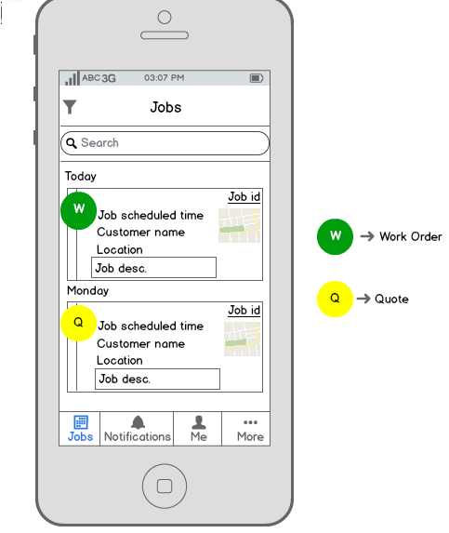

Home screen will be termed as the landing screen which would display the list of latest jobs. In case it is a work order, it will be denoted by ‘W’ or if it is a quote it will be denoted by ‘Q’. (Please refer to the above screen)
Note from Josh: The landing screen will show the schedule for the OTRW for that day, in order of jobs booked in. This could be jobs, quotes, support etc. There could also be an “office meeting” so that would lock out a selected period of time for ALL OTRW at the same time.
Seasia -- Okay
“+” Plus button will be there to Create a new job
Search bar – The employee can search the job by typing the job id.
Note from Josh: It is important that the OTRW is able to see ALL jobs assigned to them. Search function will be useful for this. Also, select by calendar. So click “next day” so they can see the jobs for tomorrow, or day after etc.
Seasia -- Done
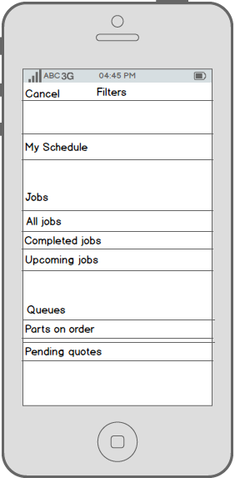
Following filters will be there in the screen:-
All Jobs – Will show all jobs
Completed Jobs – Will show Completed jobs
Upcoming Jobs – Will show upcoming jobs
Queues – Needs more clarification.
Assigned Job detail screen

This is the detail job screen which has been assigned to an employee.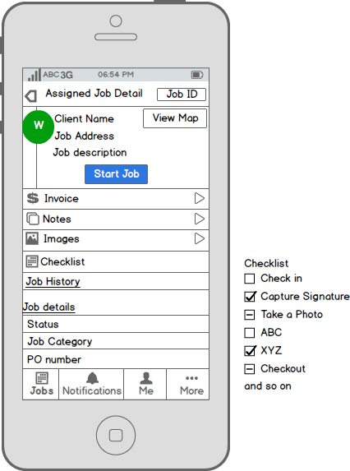

Attribute | Description | Action
Start Job | Clickable button | The employee starts the timer when the job has been started.
View map | Provides navigation to the job address. | It navigates to the detailed map view
Invoice | After completion of the job the invoice will be generated. | On clicking, the employee navigates to the detailed invoice screen.
Notes | The employee can add notes related to the job. | Navigates to the add notes screen.
Images | Employee can upload photos of the job. | Navigates to the Add image screen.
Checklist | List of task/actions | Employee would select the actions which have been done. Multiple selections can be made.  If a task requires action it would shortcut to that action. For example create a safety certificate would open that form with the customer & job details.
Job History | - | -
Job details  - Status  - PO number | Status and PO number are clickable. | - Status – The employee can set the job status as ‘completed’, ‘work order’ , ‘Quote’ or ‘No show’ (nobody was available at the job location).  - Purchase order number – in case any product or item is required for the job and has been ordered, the PO number would be displayed.

Invoice screen

Below is the invoice screen, when an employee starts a job and complete the work. In this time, invoice will be created that employee can see by clicking on invoice screen.
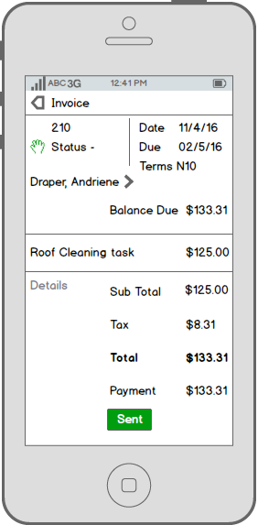
In this, employee can see the start and due date of invoice which will be notified to the customer through message or email.
Note from Josh: It is important that the OTRW can just convert the quote (if available) to an invoice. It will add the time taken, or use the time quoted. It will transfer the stock used and then produce a final price. Invoice can be signed by the client for approval. Then sent by email as PDF. To see ALL details of the current invoice please view the old online system used by the OTRW. Please refer to the invoice template also.
Seasia – Needs Clarification.

Notes
In this, employee can add notes related to his work which he has done for the assigned task.
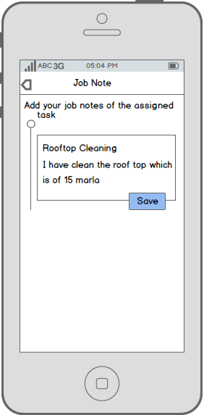
Employee can save the job note and that will notify the admin.
Note from Josh: It should just be one note box that can be edited when needed. Not multiple entries.
Seasia -- Done

Images

In this, employee can add images related his work. Like before starting a work and after ending a work. Employee can add maximum 4 images only.
Note from Josh: There should be NO limit. But please make it so the images resize.
Seasia -- Done
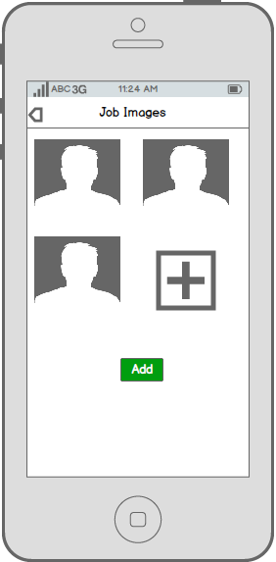

Quote order screen
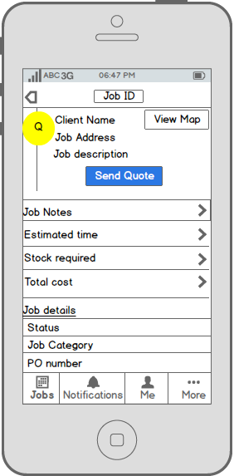
This is a screen when an admin looks for quote for particular task.
Note from Josh: This would be screen seen by OTRW logged in, NOT Admin. The worker would then process the quote. Needs ability to add ALL details related to the job/quote. The estimated time, the stock required, the total price.
DONE

Create a job
In this, employee can also create a job by going through “More option” but he cannot assign to someone. After creating a job, these own creation jobs will be listed in simple job screen.
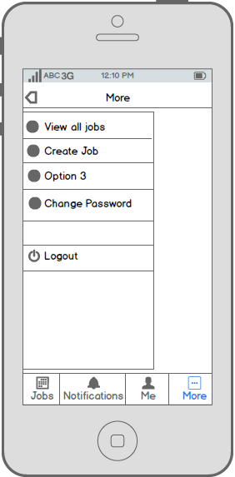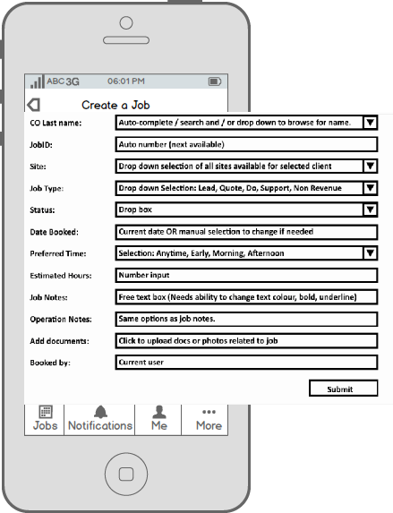
Attribute | Description | Action
Customer Name | Add customer name | NA
Job type | Select job type from drop down list as in NR, Quote etc. | NA
Lead type | Select lead type from drop down list. | NA
Job Description | Enter job description | Minimum 100 characters
Job Address | Enter job address | NA
Start and end date | Enter start and end date | NA

Note from Josh: Same process and details would be required as in the same function in FSM web version. Seasia – Okay Same functions and fields will be there.

